**Aim**

To write a C program that finds the missing elements in a sorted array of consecutive integers.

**Algorithm**

1. Start
2. Input size of array and its elements (in sorted order).
3. Find the minimum (low) and maximum (high) of the array.
4. Traverse from low to high:
   * If a number is not present in the array → print it as missing.
5. Stop

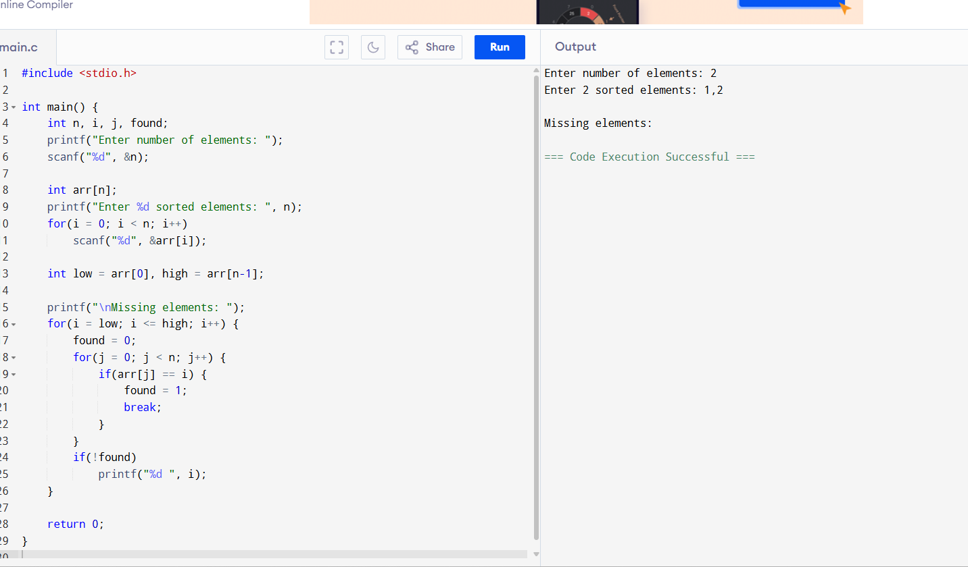

**Output**

Missing elements: 3 5 8